## Selecting objects on different layers

If you are working across multiple layers, you can switch between different objects on the fly by holding down the **CTRL + ALT** keys and clicking on desired objects in a different layer. This will switch to the layer on which the object is on, as shown below.

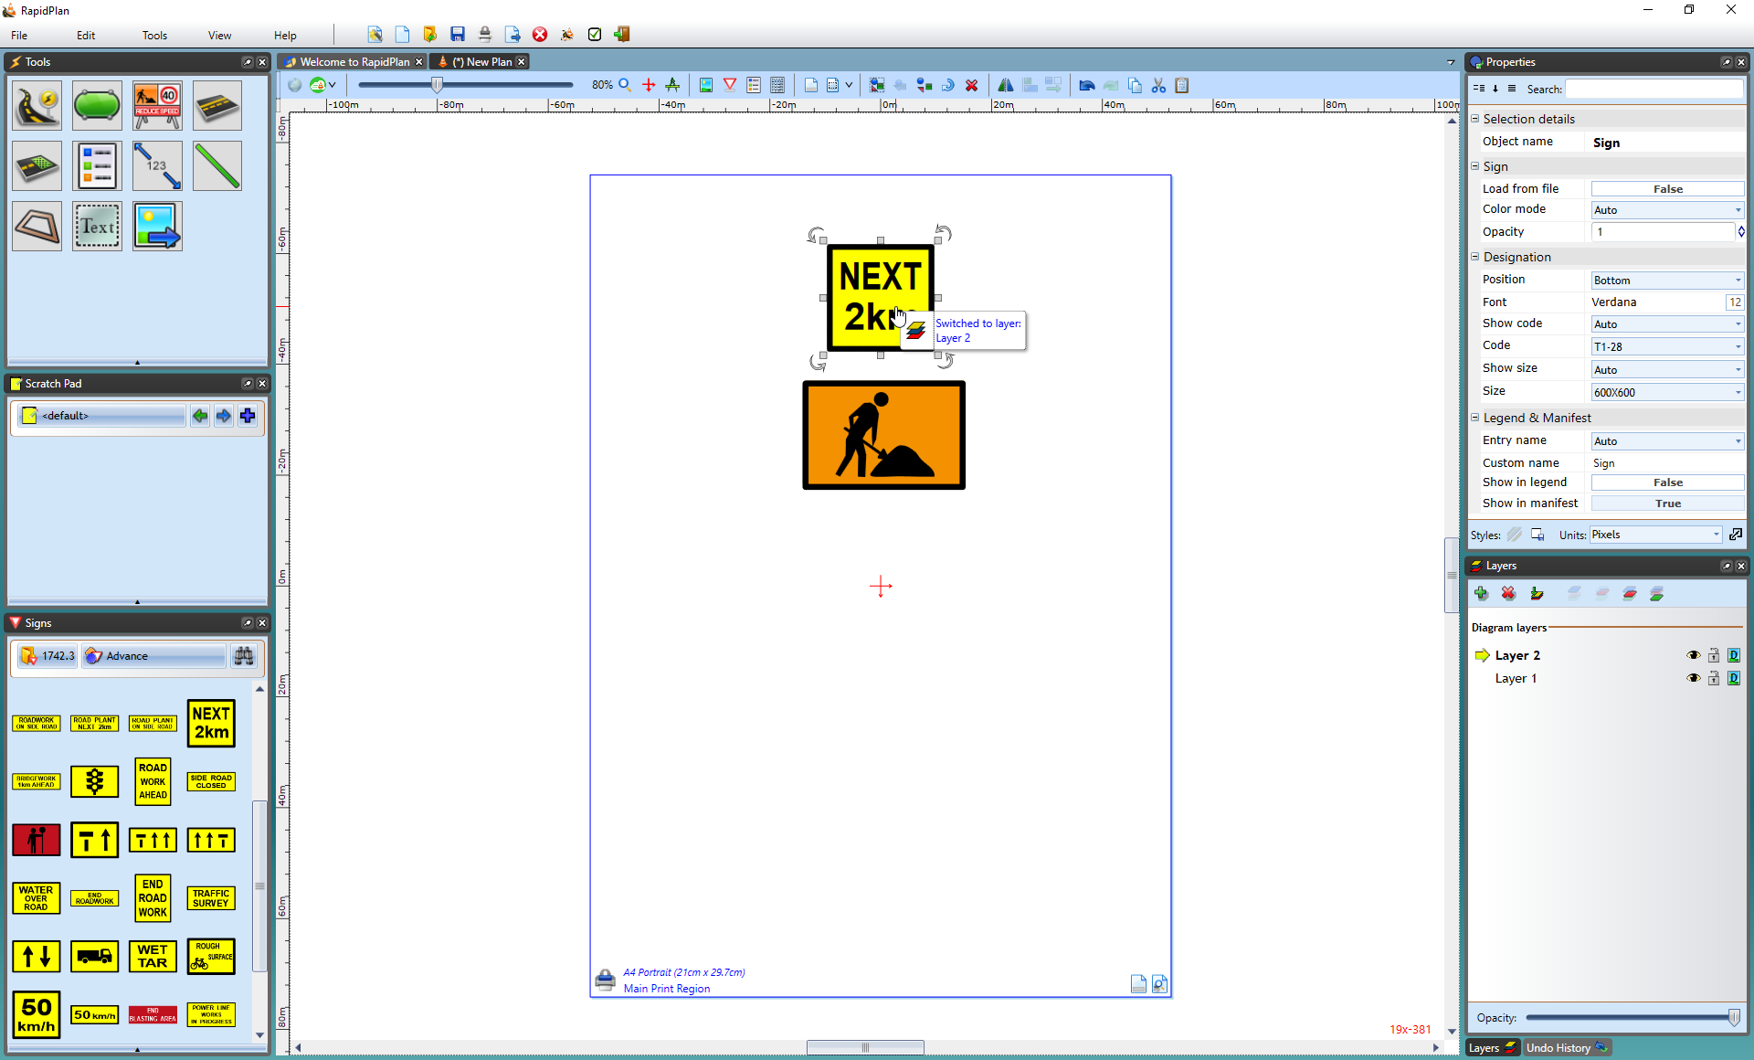

Selecting_objects_on_other_layers